SPIDEY

**About**

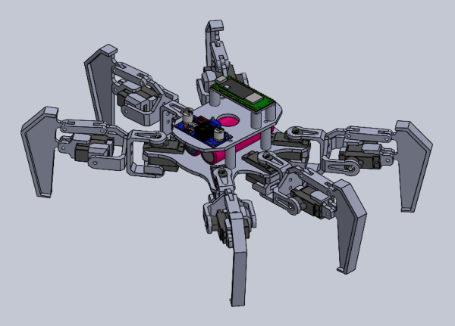

Spidey is a 12 degrees-of-freedom (DOF) hexapod robot, designed and developed for various applications such as exploration, surveillance, and search-and-rescue operations. The project aims to design and develop a hexapod robot that can operate in a wide range of environments and perform various tasks.

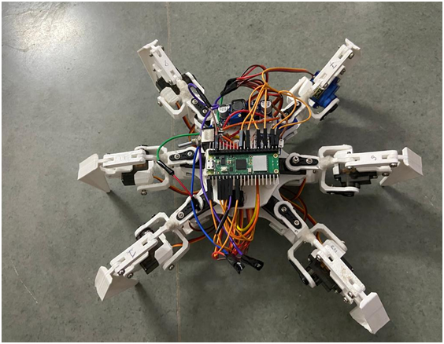

The applications of this project are diverse. Its small size makes it very maneuverable. This project aims to target defense sectors, rescue sectors departments. It can also be used in automotive industry. In cases where there is disaster, it can be very helpful in search of survivors.

**Applications**

**Future Scope**

Ankit Das – 20BEM1019 Bhajneet Singh Bedi – 20BEM1050

Harsh Mehra – 20BEM1077

**Team Members**

The project still has many milestones to achieve. Current design has 12-DOF motion which can be enhanced and increased to 18-DOF. With 18-DOF freedoms it can climb stairs, move into tiny spaces, show flexibility in movement. Overall project has great potential in various research areas.